Project Assessment Documentation
On

Tweet Recognition

For the Assessment of
MCA Fourth Semester (Shift-II)
In the Course
Programming in Python Lab (MCP629-1)

Developed by
Sagar Ninave

Under the Guidance of
Prof. Abhijit Thakre
Assistant Professor, RCOEM

Department of Computer Application
Shri Ramdeobaba College of Engineering & Management
Nagpur-13

Session: Summer 2018

Shri Ramdeobaba College of Engineering & Management
Nagpur-13



CERTIFICATE

This is to certify that the project documentation on “Tweet Recognition” is a bonafide work of Sagar Ninave submitted for assessment of MCA Fourth Semester (Shift-II) in the course Programming in Python Lab (MCP629-1) has been carried out at the Department of Computer Application, Shri Ramdeobaba College of Engineering and Management, Nagpur during the academic session summer 2018.

Date:

Prof. Abhijit Thakre Dr. P. S. Voditel
Course Coordinator/ Guide Head
Dept. of Computer Application Dept. of Computer Application

Name & Signature of
External Examiner

Index

Sr. No. | Particulars | Page No.
1. | Introduction | 1
2. | Aim and objective
3. | Technology used
4. | Program Flow Charts
5. | Coding
6. | Input and Output Screens
7. | Conclusion

- Introduction

Text mining is the application of natural language processing techniques and analytical methods to text data in order to derive relevant information. Text mining is getting a lot attention these last years, due to an exponential increase in digital text data from web pages, google's projects such as google books and google ngram, and social media services such as Twitter. Twitter data constitutes a rich source that can be used for capturing information about any topic imaginable. This data can be used in different use cases such as finding trends related to a specific keyword, measuring brand sentiment, and gathering feedback about new products and services.

- Aim and Objective

- Extract and discover knowledge hidden in text automatically
- Aid domain experts by automatically:
- Identifying concepts
- Extracting facts/relations
- Discovering implicit links
- Generating hypotheses

- Technology Used
- Python Programing Language
Python is an interpreted high-level programming language for general-purpose programming. Created by Guido van Rossum and first released in 1991, Python has a design philosophy that emphasizes code readability, notably using significant whitespace. It provides constructs that enable clear programming on both small and large scales.
- IDLE Python Editor
IDLE (short for integrated development environment or integrated development and learning environment) is an integrated development environment for Python, which has been bundled with the default implementation of the language since 1.5.2b1. It is packaged as an optional part of the Python packaging with many Linux distributions. It is completely written in Python and the Tkinter GUI toolkit (wrapper functions for Tcl/Tk).
- Twitter Open Authentication API
Twitter offers applications the ability to issue authenticated requests on behalf of the application itself (as opposed to on behalf of a specific user). Twitter’s implementation is based on the Client Credentials Grant flow of the OAuth 2 specification. Note that OAuth 1.0a is still required to issue requests on behalf of users.
With Application-only authentication you don’t have the context of an authenticated user and this means that any request to API for endpoints that require user context, such as posting Tweets, will not work. However, the set of endpoints that will still be available can have a higher rate limit.
Your app will be able to, for example:
- Pull user timelines;
- Access friends and followers of any account;
- Access lists resources;
- Search in Tweets;
- Retrieve any user information;
- Post Tweets or other resources;
- Connect to Streaming endpoints;
- Search for users;
- Use any geo endpoint;
- Access Direct Messages or account credentials;

- Tweepy Python Library
Python is great language for all sorts of things. Very active developer community creates many libraries which extend the language and make it easier to use various services. One of those libraries is tweepy. Tweepy is open-sourced, hosted on GitHub and enables Python to communicate with Twitter platform and use its API

- Program Flow Chart

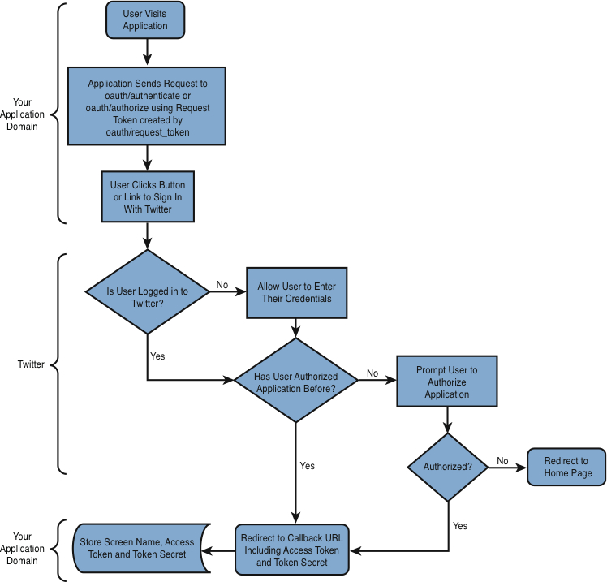

- Coding

from tweepy import Stream
from tweepy import OAuthHandler
from tweepy.streaming import StreamListener
import time

# consumer key, consumer secret, access token, access secret.
ckey="GT3xrIN0V85UdqPqUZ4E28egE"
csecret="oBzZvyTApKHxP0GSqo9lbRJ1K93CJRIovRN8zdBaic5oANGRvN"
atoken="740635692359950336-4rgBW9g1baTzcvX8rVzBBRbS08KIN39"
asecret="KgJ0LlsMeKvEIdJblamLN411HNGo3N3FezBHpJvgmu0Xa"

class listener(StreamListener):

def on_data(self, data):
tweet = data.split(',"text":"')[1].split('","source')[0]
print(tweet + "\n")
savefile = str(time.time()) + "::" + tweet
save = open('twitterDB4.csv', 'a')
save.write(savefile)
save.write("\n\n")
save.close()
return (True)

def on_error(self, status):
print(status)

auth = OAuthHandler(ckey, csecret)
auth.set_access_token(atoken, asecret)

mystr=raw_input("Enter Name to Find Person Mentioned In Paricular Tweets : ")

twitterStream = Stream(auth, listener())
twitterStream.filter(track=[mystr])

- Input and Output Screen

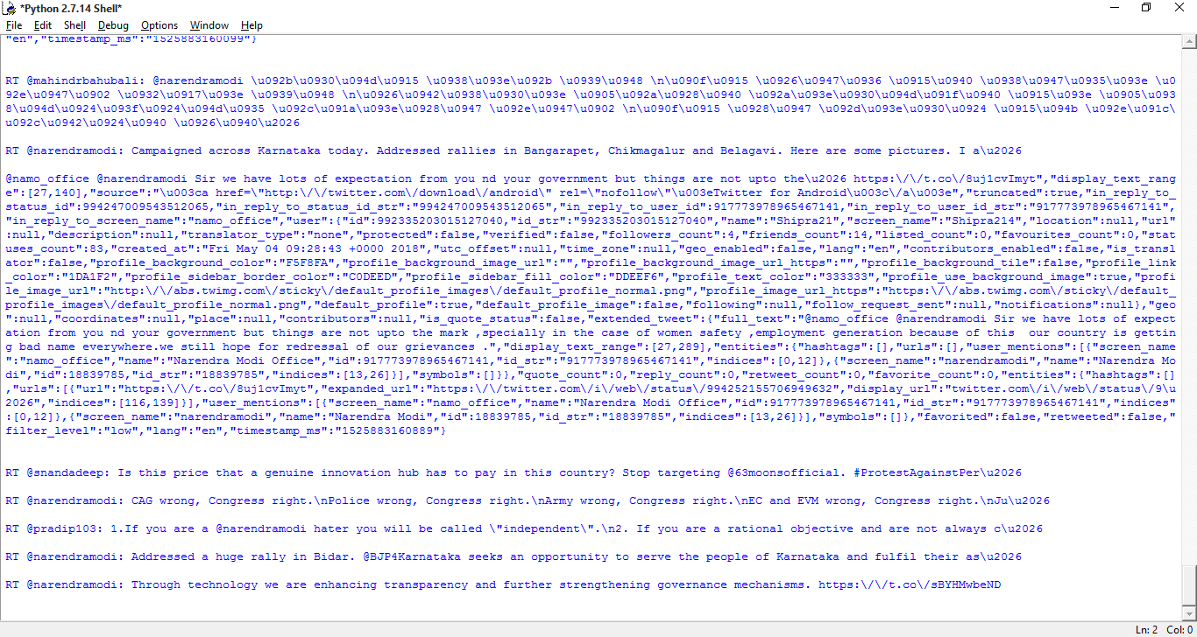

- Conclusion

Text mining is a growing technology area that is in its early days and having its own inherent complexities, similar to any emerging technology before the terms and concepts related to it are standardized. There is no accepted/definite depiction of what it should cover because of the fact that it covers different techniques to handle different problems in the text under consideration. Likewise, different text mining tools available in the market vary widely and take a slightly different path. Some fundamental text mining techniques like entity extraction, relationship between the entities, categorization, classification, summarization etc., have undergone a plenty of research and study and are apt at uncovering useful information from plain text. However, with a lot of information available on the internet presents more challenges and opportunities and more research and study needs to be done in this area. Since text mining is also considered a sibling of data mining some of the major vendors, already having data mining capabilities, are clubbing text mining with data mining to extend the value of knowledge discovery from the data. Automatic text mining techniques have a long way to go before they equal the ability of people to discover the knowledge from textual data, even without using any specific domain knowledge.

